EGR 402 – Capstone Design

Deliverable 6: Prototyping

Team Name: Blueprints

Team Members: Jordan Ziegler

  Jeremy Fischer

  Justus Karenzi

  Sudi Nsengiyumva

  Dylan Shanahan

Client’s Name: Dr. Mark Gordon

Advisor’s Name: Professor Thomas Renck

Version: 3

Date: April 9, 2015

**6.1 Hardware**

Due to this project being an application to be downloaded on a phone (currently Android only) the hardware portion is the user’s phone. For testing purposes Team Blueprints currently has a Google Nexus 7 (2014) Tablet.

**6.2 Software Structure**

As described in earlier deliverables (specifically Deliverable 5) the software breakdown is each user interface is a separate activity written within Android Studios. This allows any future changes to be easily modified based on where the changes need to be sorted out.

**6.3 Activity Design**

6.3.1 Main Menu Activity

This acts as the homepage for the overall design (can be seen in Figure 6.1). The Main Menu Activity page is an intial welcome and get started menu. In the future, if the project requires it, this page can be turned into a log in menu.

Main_Menu.Java and activity_main_menu.xml can be found in Appendix A.

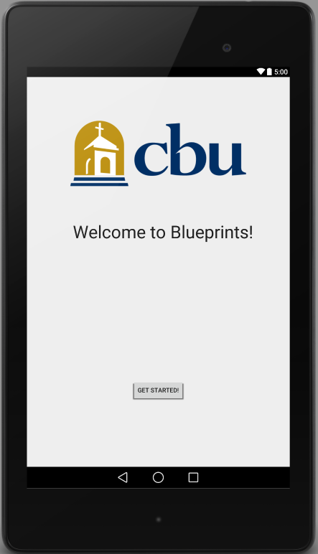

Figure 6.1 - Screenshot of Main_Menu output

6.3.2 Building Selection Activity

This allows the user to select which building they are currently in. User interface can be seen below in Figure 2. Building_Selection.Java and activity_building_selection.xml can be found in Appendix B.

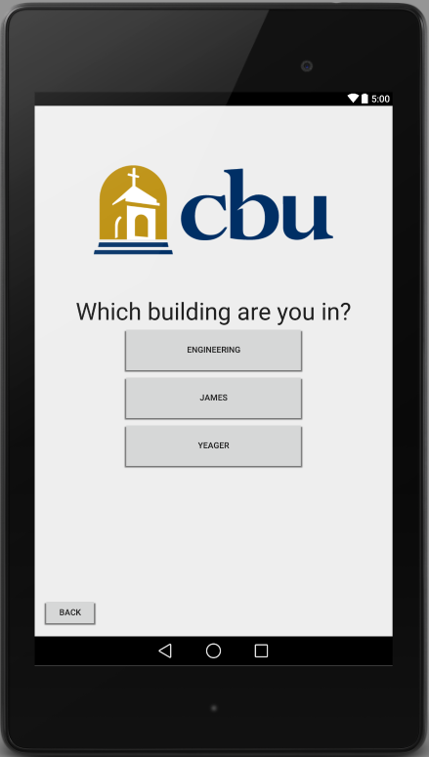

Figure 6.2 - Screenshot of Building_Selection output

6.3.3 Room Selection Activity

This allows the user to select which room they are attempting to navigate to. After the building is selected, the user is directed to the room selection page based on the building choice.

Room Selection Activity is broken down into three other activities based on user selection: Engineering, James, and Yeager. Engineering’s user interface can be seen below in Figure 6.3. James and Yeager’s user interface can be seen in Figure 6.4.

Engineering.Java and activity_engineering can be found in Appendix C.

James.Java, activity_james.xml, Yeager.Java, and activity_yeager.xml can be found in Appendix D.

*Due to James and Yeager not being important for this project the students have decided to not create pages for them but have included them for future versions.

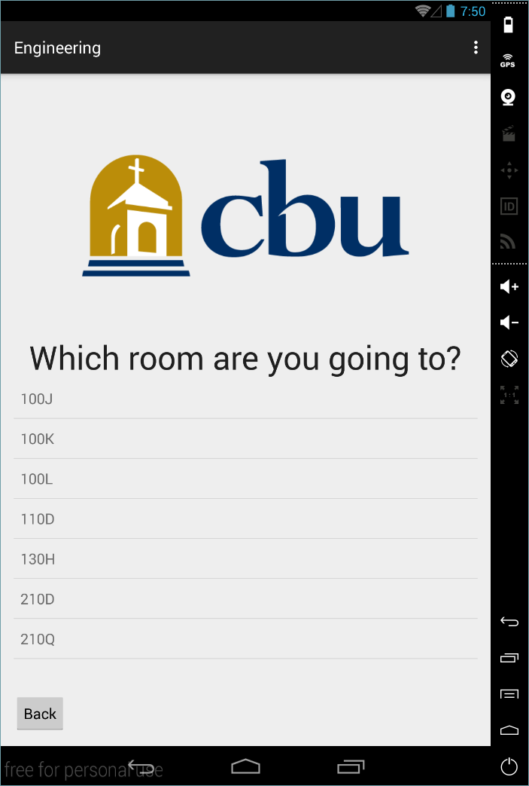

Figure 6.3 - Screenshot of Engineering output

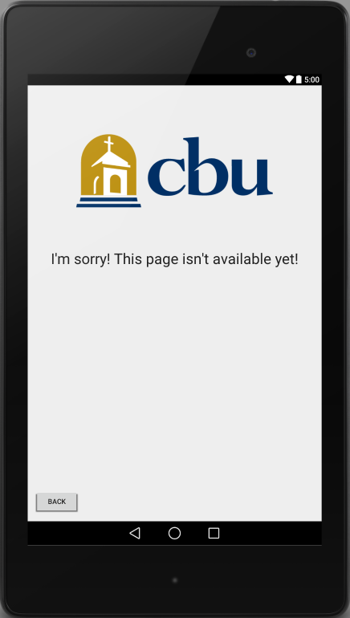

Figure 6.4 - Screenshot of James and Yeager output

**6.4 Camera Interface**

This application utilizes the phone’s back camera in order to scan signs for information. Using Vuforia’s image recognition the phone will be able to scan the signs, obtain the information (for user’s current position), and then use that information to draw from the database the information needed to direct the user to their destination.

The Camera Interface is also the area that the augmented directions will be presented to the user. Meaning the augmented reality arrows will be overlayed on top of the camera’s view, giving the user the impression that an arrow is suspended within their field of vision.

The students plan to create a Scanning window for the user to use however due to the limitations of Android Studios (along with the minimal amounts of documentation) the students are having difficulties applying this. As such they currently have this portion of the Application access the Camera application on the Phone that the user is utilizing.

Camera.java and activity_camera.xml can be found in Appendix E.

**6.5 Database Integration**

This application will be using a CSV database which contains all the Engineering rooms as well as the directions to each room. Once the camera scans a starting point (room number), then the application reads the directions from the database. Below is the proposed design of the database structure we plan to use.

The Database Code can be found in Appendix F.

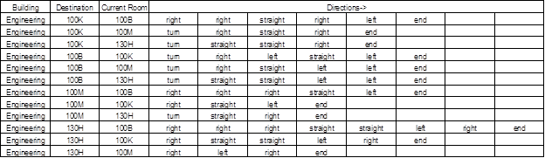

Figure 6.5 - Database Structure

**Appendices**

Appendix A

**A.1: Main_Menu.Java**

package com.example.dylan.app;

import android.content.Intent;

import android.support.v7.app.ActionBarActivity;

import android.os.Bundle;

import android.view.Menu;

import android.view.MenuItem;

import android.view.View;

import android.widget.Button;

public class Main_Menu extends ActionBarActivity {

@Override

protected void onCreate(Bundle savedInstanceState) {

super.onCreate(savedInstanceState);

setContentView(R.layout.activity_main_menu);

// Creates a simple button

Button btnSimple = (Button) findViewById(R.id.btnSimple);

btnSimple.setOnClickListener(new View.OnClickListener() {

@Override

public void onClick(View v) {

Intent intent = new Intent(v.getContext(), Building_Selection.class);

//jumps to Building_Selection Class

startActivityForResult(intent, 0);

}

});

}

@Override

public boolean onCreateOptionsMenu(Menu menu) {

// Inflate the menu; this adds items to the action bar if it is present.

getMenuInflater().inflate(R.menu.menu_main_menu, menu);

return true;

}

@Override

public boolean onOptionsItemSelected(MenuItem item) {

// Handle action bar item clicks here. The action bar will

// automatically handle clicks on the Home/Up button, so long

// as you specify a parent activity in AndroidManifest.xml.

int id = item.getItemId();

//noinspection SimplifiableIfStatement

if (id == R.id.action_settings) {

return true;

}

return super.onOptionsItemSelected(item);

}

}

**A.2: activity_main_menu.xml**

<RelativeLayout xmlns:android="http://schemas.android.com/apk/res/android"

xmlns:tools="http://schemas.android.com/tools" android:layout_width="match_parent"

android:layout_height="match_parent" android:paddingLeft="@dimen/activity_horizontal_margin"

android:paddingRight="@dimen/activity_horizontal_margin"

android:paddingTop="@dimen/activity_vertical_margin"

android:paddingBottom="@dimen/activity_vertical_margin" tools:context=".Main_Menu">

<Button android:id="@+id/btnSimple" android:layout_width="wrap_content"

android:layout_height="wrap_content" android:text="Get Started!"

android:layout_alignParentBottom="true"

android:layout_centerHorizontal="true"

android:layout_marginBottom="134dp"> </Button>

<ImageView

android:layout_width="wrap_content"

android:layout_height="wrap_content"

android:src="@drawable/cbu_logo"

android:layout_marginTop="75dp"

android:layout_alignParentTop="true"

android:layout_centerHorizontal="true"

android:id="@+id/imageView" />

<TextView

android:layout_width="wrap_content"

android:layout_height="wrap_content"

android:textAppearance="?android:attr/textAppearanceLarge"

android:text="Welcome to Blueprints!"

android:id="@+id/textView2"

android:layout_marginTop="72dp"

android:textSize="40sp"

android:layout_below="@+id/imageView"

android:layout_alignRight="@+id/imageView"

android:layout_alignEnd="@+id/imageView" />

</RelativeLayout>

Appendix B

**B.1: Building_Selection.Java**

package com.example.dylan.app;

import android.content.Intent;

import android.support.v7.app.ActionBarActivity;

import android.os.Bundle;

import android.view.Menu;

import android.view.MenuItem;

import android.view.View;

import android.widget.Button;

public class Building_Selection extends ActionBarActivity {

@Override

protected void onCreate(Bundle savedInstanceState) {

super.onCreate(savedInstanceState);

setContentView(R.layout.activity_building_selection);

Button btnSimple1 = (Button) findViewById(R.id.btnSimple1);

btnSimple1.setOnClickListener(new View.OnClickListener() {

@Override

public void onClick(View v) {

Intent intent = new Intent(v.getContext(), Main_Menu.class);

startActivityForResult(intent, 0);

}

});

Button btnSimple2 = (Button) findViewById(R.id.btnSimple2);

btnSimple2.setOnClickListener(new View.OnClickListener() {

@Override

public void onClick(View v) {

Intent intent = new Intent(v.getContext(), Engineering.class);

startActivityForResult(intent, 0);

}

});

Button btnSimple3 = (Button) findViewById(R.id.btnSimple3);

btnSimple3.setOnClickListener(new View.OnClickListener() {

@Override

public void onClick(View v) {

Intent intent = new Intent(v.getContext(), James.class);

startActivityForResult(intent, 0);

}

});

Button btnSimple4 = (Button) findViewById(R.id.btnSimple4);

btnSimple4.setOnClickListener(new View.OnClickListener() {

@Override

public void onClick(View v) {

Intent intent = new Intent(v.getContext(), Yeager.class);

startActivityForResult(intent, 0);

}

});

}

@Override

public boolean onCreateOptionsMenu(Menu menu) {

// Inflate the menu; this adds items to the action bar if it is present.

getMenuInflater().inflate(R.menu.menu_room__selection, menu);

return true;

}

@Override

public boolean onOptionsItemSelected(MenuItem item) {

// Handle action bar item clicks here. The action bar will

// automatically handle clicks on the Home/Up button, so long

// as you specify a parent activity in AndroidManifest.xml.

int id = item.getItemId();

//noinspection SimplifiableIfStatement

if (id == R.id.action_settings) {

return true;

}

return super.onOptionsItemSelected(item);

}

}

**B.2: activity_building_selection.xml**

<RelativeLayout xmlns:android="http://schemas.android.com/apk/res/android"

xmlns:tools="http://schemas.android.com/tools" android:layout_width="match_parent"

android:layout_height="match_parent" android:paddingLeft="@dimen/activity_horizontal_margin"

android:paddingRight="@dimen/activity_horizontal_margin"

android:paddingTop="@dimen/activity_vertical_margin"

android:paddingBottom="@dimen/activity_vertical_margin"

tools:context="com.example.dylan.app.Room_Selection">

<ImageView

android:layout_width="wrap_content"

android:layout_height="wrap_content"

android:src="@drawable/cbu_logo"

android:layout_marginTop="75dp"

android:layout_alignParentTop="true"

android:layout_centerHorizontal="true"

android:id="@+id/imageView" />

<Button android:id="@+id/btnSimple1"

android:layout_width="wrap_content"

android:layout_height="wrap_content"

android:text="Back"

android:layout_alignParentBottom="true"

android:layout_alignParentLeft="true"

android:layout_alignParentStart="true"> </Button>

<Button android:id="@+id/btnSimple2"

android:layout_width="300sp"

android:layout_height="80sp"

android:text="Engineering"

android:layout_below="@+id/buildingInquiry"

android:layout_centerHorizontal="true"/>

<Button android:id="@+id/btnSimple3"

android:layout_width="300sp"

android:layout_height="80sp"

android:text="James"

android:layout_below="@+id/btnSimple2"

android:layout_centerHorizontal="true"/>

<Button android:id="@+id/btnSimple4"

android:layout_width="300sp"

android:layout_height="80sp"

android:text="Yeager"

android:layout_below="@+id/btnSimple3"

android:layout_centerHorizontal="true"/>

<TextView

android:layout_width="wrap_content"

android:layout_height="wrap_content"

android:textAppearance="?android:attr/textAppearanceLarge"

android:text="Which building are you in?"

android:id="@+id/buildingInquiry"

android:layout_below="@+id/imageView"

android:layout_centerHorizontal="true"

android:layout_marginTop="63dp"

android:textSize="40sp" />

</RelativeLayout>

Appendix C

**C.1: Engineering.Java**

package com.example.dylan.app;

import android.content.Intent;

import android.support.v7.app.ActionBarActivity;

import android.os.Bundle;

import android.view.Menu;

import android.view.MenuItem;

import android.view.View;

import android.widget.AdapterView;

import android.widget.ArrayAdapter;

import android.widget.Button;

import android.widget.ListAdapter;

import android.widget.ListView;

public class Engineering extends ActionBarActivity {

@Override

protected void onCreate(Bundle savedInstanceState) {

super.onCreate(savedInstanceState);

setContentView(R.layout.activity_engineering);

String[] classrooms = {"100J","100K","100L","110D","130H","210D","210Q"};

ListAdapter theAdapter = new ArrayAdapter<String>(this,android.R.layout.simple_list_item_1,classrooms);

ListView listView = (ListView) findViewById(R.id.listView);

listView.setAdapter(theAdapter);

listView.setOnItemClickListener(new AdapterView.OnItemClickListener() {

@Override

public void onItemClick(AdapterView<?> parent, View v, int i, long id) {

Intent intent = new Intent(v.getContext(), Yeager.class);

startActivityForResult(intent, 0);

}

});

Button btnSimple1 = (Button) findViewById(R.id.btnSimple1);

btnSimple1.setOnClickListener(new View.OnClickListener() {

@Override

public void onClick(View v) {

Intent intent = new Intent(v.getContext(), Building_Selection.class);

startActivityForResult(intent, 0);

}

});

}

@Override

public boolean onCreateOptionsMenu(Menu menu) {

// Inflate the menu; this adds items to the action bar if it is present.

getMenuInflater().inflate(R.menu.menu_engineering, menu);

return true;

}

@Override

public boolean onOptionsItemSelected(MenuItem item) {

// Handle action bar item clicks here. The action bar will

// automatically handle clicks on the Home/Up button, so long

// as you specify a parent activity in AndroidManifest.xml.

int id = item.getItemId();

//noinspection SimplifiableIfStatement

if (id == R.id.action_settings) {

return true;

}

return super.onOptionsItemSelected(item);

}

}

**C.2: activity_engineering.xml**

<RelativeLayout xmlns:android="http://schemas.android.com/apk/res/android"

xmlns:tools="http://schemas.android.com/tools" android:layout_width="match_parent"

android:layout_height="match_parent" android:paddingLeft="@dimen/activity_horizontal_margin"

android:paddingRight="@dimen/activity_horizontal_margin"

android:paddingTop="@dimen/activity_vertical_margin"

android:paddingBottom="@dimen/activity_vertical_margin"

tools:context="com.example.dylan.app.Engineering">

<ImageView

android:layout_width="wrap_content"

android:layout_height="wrap_content"

android:src="@drawable/cbu_logo"

android:layout_marginTop="75dp"

android:layout_alignParentTop="true"

android:layout_centerHorizontal="true"

android:id="@+id/imageView" />

<Button android:id="@+id/btnSimple1"

android:layout_width="wrap_content"

android:layout_height="wrap_content"

android:text="Back"

android:layout_alignParentBottom="true"

android:layout_alignParentLeft="true"

android:layout_alignParentStart="true"> </Button>

<TextView

android:layout_width="wrap_content"

android:layout_height="wrap_content"

android:textAppearance="?android:attr/textAppearanceLarge"

android:text="Which room are you going to?"

android:id="@+id/roomInquiry"

android:layout_below="@+id/imageView"

android:layout_centerHorizontal="true"

android:layout_marginTop="63dp"

android:textSize="40sp" />

<ListView

android:layout_width="wrap_content"

android:layout_height="wrap_content"

android:id="@+id/listView"

android:layout_below="@+id/roomInquiry"

android:layout_alignParentLeft="true"

android:layout_alignParentStart="true"

android:layout_above="@+id/btnSimple1"

android:choiceMode="singleChoice" />

</RelativeLayout>

Appendix D

**D.1: James.Java**

package com.example.dylan.app;

import android.content.Intent;

import android.support.v7.app.ActionBarActivity;

import android.os.Bundle;

import android.view.Menu;

import android.view.MenuItem;

import android.view.View;

import android.widget.Button;

public class James extends ActionBarActivity {

@Override

protected void onCreate(Bundle savedInstanceState) {

super.onCreate(savedInstanceState);

setContentView(R.layout.activity_james);

Button btnSimple = (Button) findViewById(R.id.btnSimple);

btnSimple.setOnClickListener(new View.OnClickListener() {

@Override

public void onClick(View v) {

Intent intent = new Intent(v.getContext(), Building_Selection.class);

startActivityForResult(intent, 0);

}

});

}

@Override

public boolean onCreateOptionsMenu(Menu menu) {

// Inflate the menu; this adds items to the action bar if it is present.

getMenuInflater().inflate(R.menu.menu_james, menu);

return true;

}

@Override

public boolean onOptionsItemSelected(MenuItem item) {

// Handle action bar item clicks here. The action bar will

// automatically handle clicks on the Home/Up button, so long

// as you specify a parent activity in AndroidManifest.xml.

int id = item.getItemId();

//noinspection SimplifiableIfStatement

if (id == R.id.action_settings) {

return true;

}

return super.onOptionsItemSelected(item);

}

}

**D.2: activity_james.xml**

<RelativeLayout xmlns:android="http://schemas.android.com/apk/res/android"

xmlns:tools="http://schemas.android.com/tools" android:layout_width="match_parent"

android:layout_height="match_parent" android:paddingLeft="@dimen/activity_horizontal_margin"

android:paddingRight="@dimen/activity_horizontal_margin"

android:paddingTop="@dimen/activity_vertical_margin"

android:paddingBottom="@dimen/activity_vertical_margin"

tools:context="com.example.dylan.app.James">

<ImageView

android:layout_width="wrap_content"

android:layout_height="wrap_content"

android:src="@drawable/cbu_logo"

android:layout_marginTop="75dp"

android:layout_alignParentTop="true"

android:layout_centerHorizontal="true"

android:id="@+id/imageView" />

<TextView

android:layout_width="wrap_content"

android:layout_height="wrap_content"

android:textAppearance="?android:attr/textAppearanceLarge"

android:text="I&apos;m sorry! This page isn&apos;t available yet!"

android:id="@+id/textView"

android:layout_below="@+id/imageView"

android:layout_centerHorizontal="true"

android:layout_marginTop="78dp"

android:textSize="30sp" />

<Button android:id="@+id/btnSimple"

android:layout_width="wrap_content"

android:layout_height="wrap_content"

android:text="Back"

android:layout_alignParentBottom="true"

android:layout_alignParentLeft="true"

android:layout_alignParentStart="true"> </Button>

</RelativeLayout>

**D.3: Yeager.Java**

package com.example.dylan.app;

import android.content.Intent;

import android.support.v7.app.ActionBarActivity;

import android.os.Bundle;

import android.view.Menu;

import android.view.MenuItem;

import android.view.View;

import android.widget.Button;

public class Yeager extends ActionBarActivity {

@Override

protected void onCreate(Bundle savedInstanceState) {

super.onCreate(savedInstanceState);

setContentView(R.layout.activity_yeager);

Button btnSimple = (Button) findViewById(R.id.btnSimple);

btnSimple.setOnClickListener(new View.OnClickListener() {

@Override

public void onClick(View v) {

Intent intent = new Intent(v.getContext(), Building_Selection.class);

startActivityForResult(intent, 0);

}

});

}

@Override

public boolean onCreateOptionsMenu(Menu menu) {

// Inflate the menu; this adds items to the action bar if it is present.

getMenuInflater().inflate(R.menu.menu_yeager, menu);

return true;

}

@Override

public boolean onOptionsItemSelected(MenuItem item) {

// Handle action bar item clicks here. The action bar will

// automatically handle clicks on the Home/Up button, so long

// as you specify a parent activity in AndroidManifest.xml.

int id = item.getItemId();

//noinspection SimplifiableIfStatement

if (id == R.id.action_settings) {

return true;

}

return super.onOptionsItemSelected(item);

}

}

**D.4: activity_yeager.xml**

<RelativeLayout xmlns:android="http://schemas.android.com/apk/res/android"

xmlns:tools="http://schemas.android.com/tools" android:layout_width="match_parent"

android:layout_height="match_parent" android:paddingLeft="@dimen/activity_horizontal_margin"

android:paddingRight="@dimen/activity_horizontal_margin"

android:paddingTop="@dimen/activity_vertical_margin"

android:paddingBottom="@dimen/activity_vertical_margin"

tools:context="com.example.dylan.app.Yeager">

<ImageView

android:layout_width="wrap_content"

android:layout_height="wrap_content"

android:src="@drawable/cbu_logo"

android:layout_marginTop="75dp"

android:layout_alignParentTop="true"

android:layout_centerHorizontal="true"

android:id="@+id/imageView" />

<TextView

android:layout_width="wrap_content"

android:layout_height="wrap_content"

android:textAppearance="?android:attr/textAppearanceLarge"

android:text="I&apos;m sorry! This page isn&apos;t available yet!"

android:id="@+id/textView"

android:layout_below="@+id/imageView"

android:layout_centerHorizontal="true"

android:layout_marginTop="78dp"

android:textSize="30sp" />

<Button android:id="@+id/btnSimple"

android:layout_width="wrap_content"

android:layout_height="wrap_content"

android:text="Back"

android:layout_alignParentBottom="true"

android:layout_alignParentLeft="true"

android:layout_alignParentStart="true"> </Button>

</RelativeLayout>

Appendix E

**E.1: Camera.java**

package com.example.dylan.app;

import android.content.Context;

import android.support.v7.app.ActionBarActivity;

import android.os.Bundle;

import android.view.Menu;

import android.view.MenuItem;

import android.view.SurfaceHolder;

import android.view.SurfaceView;

import android.view.View;

import android.widget.FrameLayout;

import java.io.IOException;

public class Camera extends ActionBarActivity {

@Override

protected void onCreate(Bundle savedInstanceState) {

super.onCreate(savedInstanceState);

setContentView(R.layout.activity_camera);

}

private boolean safeCameraOpenInView(View view) {

boolean qOpened = false;

releaseCameraAndPreview();

Camera mCamera = getCameraInstance();

qOpened = (mCamera != null);

mPreview = new CameraPreview(getActivity().getBaseContext(), mCamera);

FrameLayout preview = (FrameLayout) view.findViewById(R.id.camera_preview);

preview.addView(mPreview);

return qOpened;

}

@Override

public boolean onCreateOptionsMenu(Menu menu) {

// Inflate the menu; this adds items to the action bar if it is present.

getMenuInflater().inflate(R.menu.menu_camera, menu);

return true;

}

@Override

public boolean onOptionsItemSelected(MenuItem item) {

// Handle action bar item clicks here. The action bar will

// automatically handle clicks on the Home/Up button, so long

// as you specify a parent activity in AndroidManifest.xml.

int id = item.getItemId();

//noinspection SimplifiableIfStatement

if (id == R.id.action_settings) {

return true;

}

return super.onOptionsItemSelected(item);

}

public Camera getCameraInstance() {

return cameraInstance;

}

}

class CameraPreview extends SurfaceView implements SurfaceHolder.Callback {

SurfaceHolder mHolder;

Camera mCamera;

public CameraPreview(Context context, Camera camera) {

super(context);

mCamera = camera;

mHolder = getHolder();

mHolder.addCallback(this);

mHolder.setType(SurfaceHolder.SURFACE_TYPE_PUSH_BUFFERS);

}

public void surfaceCreated(SurfaceHolder holder) {

try {

mCamera.setPreviewDisplay(holder);

mCamera.startPreview();

} catch (IOException e) {

e.printStackTrace();

}

}

public void surfaceDestroyed(SurfaceHolder holder) {

}

public void surfaceChanged(SurfaceHolder holder, int format, int w, int h) {

if (mHolder.getSurface() == null) {

return;

}

try {

mCamera.stopPreview();

} catch (Exception e){

}

try {

mCamera.setPreviewDisplay(mHolder);

mCamera.startPreview();

}

}

}

**E.2: activity_camera.xml**

<RelativeLayout xmlns:android="http://schemas.android.com/apk/res/android"

xmlns:tools="http://schemas.android.com/tools" android:layout_width="match_parent"

android:layout_height="match_parent" android:paddingLeft="@dimen/activity_horizontal_margin"

android:paddingRight="@dimen/activity_horizontal_margin"

android:paddingTop="@dimen/activity_vertical_margin"

android:paddingBottom="@dimen/activity_vertical_margin"

tools:context="com.example.dylan.app.Camera">

</RelativeLayout>

Appendix F

**Database code**

public final List<String[]> readCsv(Context context) {

List<String[]> questionList = new ArrayList<String[]>();

AssetManager assetManager = context.getAssets();

try {

InputStream csvStream = assetManager.open(CSV_PATH); // insert path where it says "CSV_PATH"

InputStreamReader csvStreamReader = new InputStreamReader(csvStream);

CSVReader csvReader = new CSVReader(csvStreamReader);

String[] line;

// throw away the header

csvReader.readNext();

String Split = ',';

while ((line = csvReader.readNext()) != null) {

//destination 100K

String []b = line.split(splitBy);

if(b[1] = "100K" && b[2] = "100B"){

questionList.add(line);

//these lines contains directions from current room read from camera

}

//copy above code example for all cases

//destination 100B

if else (line == "100B"){

questionList.add(line);

//these lines contains directions from current room read from camera

}

//destination 100M

if else (line == "100M"){

questionList.add(line);

//these lines contains directions from current room read from camera

}

//destination 130H

if else (line == "130H"){

questionList.add(line);

//these lines contains directions from current room read from camera

}

}

} catch (IOException e) {

e.printStackTrace();

}

return questionList;

}

Appendix G

**AndroidManifest.xml**

<?xml version="1.0" encoding="utf-8"?>

<manifest xmlns:android="http://schemas.android.com/apk/res/android"

package="com.example.dylan.app" >

<uses-permission android:name="android.permission.CAMERA" />

<uses-feature android:name="android.hardware.camera"

android:required="true"/>

<uses-feature android:name="android.hardware.camera.autofocus" />

<application

android:allowBackup="true"

android:icon="@drawable/ic_launcher"

android:label="@string/app_name"

android:theme="@style/AppTheme" >

<activity

android:name=".Main_Menu"

android:label="@string/app_name" >

<intent-filter>

<action android:name="android.intent.action.MAIN" />

<category android:name="android.intent.category.LAUNCHER" />

</intent-filter>

</activity>

<activity

android:name=".Building_Selection"

android:label="@string/title_activity_room__selection" >

</activity>

<activity

android:name=".Engineering"

android:label="@string/title_activity_engineering" >

</activity>

<activity

android:name=".James"

android:label="@string/title_activity_james" >

</activity>

<activity

android:name=".Yeager"

android:label="@string/title_activity_yeager" >

</activity>

<activity

android:name=".Camera"

android:label="@string/title_activity_camera" >

</activity>

</application>

</manifest>